Greater New Hampshire Linux User Group

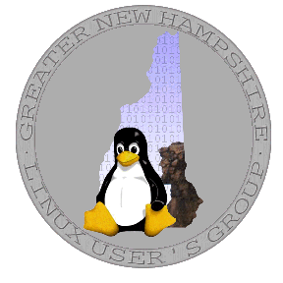
Who Are We?
We share a common interest in Linux and Free/Open Source Software (FOSS). Our range of skills, experiences and interests is diverse. We are hobbyists, amateurs, professionals, system administrators, developers, lawyers, students, world-renowned experts and beginners. We share an interest in learning more and in helping each other. Membership in the GNHLUG is open to all with no membership fee

What Do We Do?
Representatives of the group can often be found at computer conferences or other meetings giving presentations, offering insights or advocating for Linux or FOSS. Several chapters of the group meet for social and educational purposes (see the schedule below). At the meetings, there is usually a demonstration of a program of interest and almost always an opportunity to ask questions. There is an active mailing list where you can seek support for problems or ask questions. There are also several very-low-traffic mailing lists for meeting announcements. We are also active in advocating for FOSS in our state businesses, governments and school systems.

When and Where Do We Meet?
Currently, there are five chapters meeting around the state:
When | Who | Where | Details
First Monday | CentraLUG Concord | NHTI, Concord | www.gnhlug.org
First Thursday | Dartmouth Lake Sunapee LUG | Dartmouth College, Hanover | www.dlslug.org
Second Monday | Seacoast LUG | UNH Durham | slug.gnhlug.org
Second Thursday | Monadnock LUG | SAU 1 offices in Peterborough | www.gnhlug.org
Third Thursday | Ruby/Rails SIG | Portsmouth | www.nhruby.org
Fourth Thursday | Python SIG | ABI, Manchester | www.pysig.org
Meetings typically start at 7 PM (dinner beforehand is optional) and network before and after the meeting is encouraged. While these are the usual meeting times and places, check the calendar and join the mailing list to ensure you know of the proper place, time and agenda, as this often helps with issues such as snow cancellations.

How Can You Participate?
- Attend the meetings. Meetings are open to the public at no charge.
- Visit the web site at http://www.gnhlug.org to learn more about us.
- Join the mailing lists listed at http://mail.gnhlug.org/mailman/listinfo.

